**CHAPTER THREE: RESEARCH METHODOLOGY**

**INTRODUCTION**

This chapter outlines the methodological framework employed to investigate the spatiotemporal dynamics and climatic drivers of extreme precipitation events in Ghana. Given the complex nature of rainfall extremes and their connection to both local and large-scale atmospheric systems, the study adopts a quantitative descriptive and analytical research design. This approach enables the objective measurement of climatic variables, detection of statistical patterns, and exploration of causal atmospheric mechanisms using observational and reanalysis datasets.

The methodology integrates multiple analytical components, including trend detection, seasonal analysis, spatial mapping, and composite interpretation. It draws upon daily precipitation data from 22 Ghana Meteorological Agency (GMET) synoptic stations covering the period 1990 to 2024, alongside climate indices such as ENSO phases.

Detailed attention is given to data quality control, including screening for outliers and homogenization of time series, as well as the use of Python, R, and QGIS for statistical and spatial analyses. By combining station-based observations with gridded atmospheric fields, the chapter presents a robust framework for understanding both the temporal behavior and atmospheric precursors of extreme rainfall. The methodologies described here lay the foundation for the results and interpretations presented in the subsequent chapter.

**RESEARCH DESIGN**

**Overview of Research Philosophy and Approach**

This study adopts a quantitative research philosophy grounded in the positivist epistemological paradigm, which emphasizes objective measurement, empirical observation, and the identification of statistical regularities in natural phenomena (Lincoln et al., 1985). In the context of climate science, and more specifically the investigation of extreme precipitation events, this approach is essential for ensuring the validity, replicability, and generalizability of findings. Positivism underpins the belief that climatic events can be objectively quantified and that their underlying causes can be explored through observable atmospheric patterns and statistically verifiable relationships (Goodson & Phillimore, 2004).

The quantitative research philosophy is especially well-suited to this study, which seeks to examine the long-term trends, seasonality, and atmospheric drivers of extreme rainfall in Ghana (Owens et al., 2016). These objectives necessitate the use of numeric datasets, such as daily rainfall measurements from 22 synoptic stations which lend themselves naturally to quantitative analysis. The approach assumes a deterministic relationship between atmospheric phenomena (e.g., Rainfall, Temperature, SST variability, synoptic wind fields) and surface-level rainfall, allowing for the formulation and testing of hypotheses regarding their influence on precipitation extremes (Evans et al., 2017).

The study employs a descriptive and analytical research design, which involves two core dimensions. The descriptive component focuses on summarizing and characterizing patterns in the historical data, including the frequency, intensity, and spatial distribution of extreme rainfall events (Alam & Saddik, 2017). This aspect is particularly important for establishing a baseline understanding of precipitation extremes across Ghana’s diverse ecological and climatic zones.

The analytical dimension, on the other hand, involves the use of inferential statistical techniques and diagnostic tools to assess trends, correlations, and causal linkages between observed rainfall extremes and atmospheric variables (Islam et al., 2021). The analytical framework includes the Mann-Kendall trend test, Sen’s slope estimator, return period estimation through Gumbel distributions, composite anomaly analysis, and mapping of synoptic fields using reanalysis data. These tools enable the study to move beyond simple description toward explanatory analysis that can identify underlying mechanisms and forecast-relevant patterns.

This philosophical and methodological orientation supports the primary aim of the study: to produce evidence-based insights into the nature and drivers of extreme precipitation events in Ghana. By relying on measurable, statistically verifiable data and analytical rigor, the study contributes to a more robust understanding of climatic hazards and enhances the scientific basis for early warning systems, infrastructure planning, and climate adaptation policy in the Ghanaian context (Chitando et al., 2022).

**Quantitative Descriptive and Analytical Framework**

This study employs a quantitative descriptive and analytical framework to systematically investigate the spatiotemporal dynamics and climatic drivers of extreme precipitation events in Ghana. The framework is grounded in the principles of quantitative climatology, where empirical evidence is derived from objective, numerical data and subjected to statistical scrutiny to reveal patterns, associations, and underlying mechanisms (Bauer & Scheim, 2019).

The descriptive component of the framework focuses on summarizing historical precipitation patterns based on daily rainfall observations from 22 synoptic stations across Ghana for the period 1990 to 2024. Key statistical summaries—including means, medians, standard deviations, and percentiles—are computed to characterize the intensity, frequency, and seasonal distribution of rainfall extremes. Percentile thresholds, particularly the 90th and 95th percentiles, are applied to define extreme precipitation events relative to the long-term climatology of each station. These definitions allow for consistency across locations while respecting local rainfall regimes (Chuvieco et al., 2019).

In addition, descriptive statistics are used to compute the annual and seasonal climatology of extreme events, identifying peak months and interannual variability. Boxplots, time series plots, and seasonal indices are employed to visualize and interpret intra-annual and inter-decadal shifts in precipitation extremes.

The analytical component integrates inferential statistical techniques to detect trends and explore relationships between observed rainfall extremes and large-scale atmospheric conditions (Lozo & Onishchenko, 2021). The Mann-Kendall trend test (Alhaji et al., 2018), a non-parametric method widely used in climate studies, is applied to assess the presence of statistically significant monotonic trends in the frequency and intensity of extreme events over the 34-year period. The Sen’s slope estimator is used to quantify the magnitude and direction of these trends, providing insight into the rate of change in precipitation extremes.

To further analyze the recurrence behavior of extreme rainfall, the study employs extreme value theory, specifically the Gumbel distribution, to estimate return periods for high-intensity events (Bob, 2013). This analysis is critical for understanding the likelihood of rare but high-impact events and is directly relevant to infrastructure design and disaster risk management.

The combination of descriptive and analytical methods enhances the study’s ability to move from simple pattern recognition to a more mechanistic understanding of extreme rainfall behavior in Ghana. It allows for the integration of surface-level observations with upper-air diagnostics and provides a comprehensive quantitative basis for evaluating both temporal trends and spatial distributions of climate extremes.

**Integration of Trend Detection, Spatial Analysis, and Synoptic Interpretation**

A distinctive feature of this study’s methodological design is the integration of trend detection, spatial analysis, and synoptic interpretation, which collectively enables a multidimensional understanding of extreme precipitation dynamics across Ghana (Wulder et al., 2012). This integrative approach bridges the gap between statistical characterization and meteorological explanation, offering both temporal precision and atmospheric context to the patterns observed.

The trend detection component is rooted in time-series analysis, wherein the historical progression of extreme precipitation events is quantified for each synoptic station from 1990 to 2024. This involves the computation of annual and seasonal frequencies and intensities of rainfall events exceeding percentile thresholds (e.g., 90th or 95th percentiles). The Mann-Kendall test is applied to detect the presence of monotonic trends, while Sen’s slope estimator provides the magnitude of change over time. These tools allow for the identification of statistically significant increases or decreases in the frequency and severity of extreme rainfall events, forming a basis for assessing long-term climate variability (Miró et al., 2022).

While trend detection yields valuable temporal insights, it is insufficient in isolation, particularly in a geographically diverse context like Ghana. Therefore, the study integrates spatial analysis using cartographic tools in QGIS and Python. Spatial maps are generated to visualize the geographical distribution of extreme event metrics such as frequency, intensity, and return periods (Gann et al., 2019). This spatial dimension reveals regional hotspots of vulnerability and allows comparisons across ecological zones, enhancing the relevance of findings for location-specific planning and disaster management.

Together, these three methodological pillars provide a holistic analytical framework. Temporal trends highlight evolving climate risks; spatial analysis identifies geographical differentials; and synoptic diagnostics offer mechanistic explanations. This integration is essential not only for enhancing scientific understanding but also for informing practical interventions in flood risk reduction, infrastructure planning, and seasonal climate forecasting (Simsek et al., 2020).

**DATA SOURCES**

This study draws on two primary sources of climate data: (1) observational station-based rainfall data from the Ghana Meteorological Agency (GMET). These datasets form the basis for the spatiotemporal, statistical, and synoptic analyses undertaken in the study.

**GMET Daily Rainfall Data (1990–2024)**

The core dataset for surface-level precipitation analysis is derived from daily rainfall observations collected at 22 synoptic stations across Ghana. These stations are strategically distributed to cover diverse agroecological zones, including the coastal savannah, forest, transitional, and northern savannah zones.

The rainfall data spans a 34-year period from January 1, 1990, to December 31, 2024, and includes measurements recorded in millimeters (mm) per day. The data is used to compute:

* Frequency and intensity of extreme rainfall events based on percentile thresholds (90th and 95th percentiles).
* Monthly and seasonal climatologies of extreme events.
* Annual return periods of heavy rainfall occurrences.

This dataset is crucial for characterizing local trends, seasonality, and station-level anomalies in precipitation behavior.

**ENSO Phase Data (El Niño, La Niña, Neutral)**

The ENSO phenomenon is one of the most influential climate systems affecting tropical rainfall (Hao et al., 2018). It operates through sea surface temperature (SST) anomalies in the central and eastern Pacific Ocean and associated atmospheric pressure shifts (i.e., the Southern Oscillation). ENSO is typically categorized into three phases:

* El Niño: Characterized by above-average SSTs in the equatorial Pacific and typically associated with suppressed rainfall in parts of West Africa, depending on timing and intensity.
* La Niña: Marked by below-average SSTs and often linked to enhanced rainfall over the Sahel and parts of Ghana, though effects can be spatially heterogeneous.
* Neutral: Conditions where SST anomalies do not meet the thresholds for either El Niño or La Niña.

ENSO phases as indicated by Hao et al. (2018)are used to:

* Categorize years for composite anomaly analysis of atmospheric variables (e.g., SST, wind, geopotential height);
* Explore differences in extreme rainfall behavior across different ENSO conditions;
* Assess the extent to which ENSO influences interannual rainfall variability in Ghana.

**Pre-Processing of GMET Station Data**

The reliability and accuracy of trend and extreme event analyses are contingent upon the quality of input data (Dwivedi et al., 2019). As such, the GMET station-based rainfall data underwent rigorous pre-processing procedures to ensure consistency, completeness, and comparability across stations and years. The following steps were undertaken to prepare the daily precipitation dataset from the 22 selected synoptic stations for robust quantitative analysis.

**Handling of Missing Values**

One of the most common challenges in climatological datasets is the presence of missing values due to instrument failure, reporting delays, or data recording errors. The initial stage of pre-processing involved a comprehensive assessment of data completeness for each station and year within the 1990–2024 period.

A station was retained for analysis only if it had at least 90% of daily data completeness per year across the 34-year period. For missing daily values within acceptable thresholds, linear interpolation or climatological mean substitution was applied based on surrounding days, weeks, or long-term station averages. However, stations with large, persistent data gaps (exceeding 10% missingness annually or with missing entire wet seasons) were excluded from final analysis to avoid bias and misrepresentation in extreme event identification.

**Detection and Treatment of Outliers**

Outliers, such as unusually high daily rainfall totals, may be indicative of data entry errors, instrument faults, or actual rare events. Therefore, a threshold-based outlier detection approach was adopted. Rainfall values exceeding the 99.9th percentile of the climatological distribution at each station were flagged for verification.

These flagged values were reviewed in the context of:

* Adjacent days’ rainfall amounts,
* Historical meteorological reports (e.g., storm activity),
* Cross-station comparisons within the same climatological zone.

Where inconsistencies or errors were confirmed, values were either corrected (if metadata allowed) or treated as missing and imputed accordingly. True extreme values were retained and incorporated into event statistics.

**Homogeneity Testing**

To ensure that detected trends in extreme precipitation were climatic and not artifacts of instrumentation changes, station relocations, or observer bias, homogeneity tests were applied to each station’s time series. The following methods were used:

* Standard Normal Homogeneity Test (SNHT) for both mean shifts and variance changes;
* Pettitt’s Test, a non-parametric method suitable for detecting single change-points in time series.

Stations exhibiting statistically significant inhomogeneities were examined in relation to known metadata (e.g., instrument upgrades), and data were adjusted if the change point could be attributed to non-climatic factors. Otherwise, the affected subseries was flagged or truncated to retain homogeneity.

**Standardization and Formatting**

Following quality checks, the cleaned daily rainfall datasets were standardized into uniform formats (CSV and Pandas DataFrame structure in Python). Daily precipitation units were kept in millimeters (mm), and timestamps were standardized to reflect calendar dates (YYYY-MM-DD). Each station dataset included the following columns:

* Date,
* Daily Rainfall Total,
* Event Flag (if above threshold),
* Station ID.

These pre-processed and harmonized datasets formed the baseline for trend analysis, threshold exceedance calculation, and event tagging in subsequent phases of the study.

**Use of Python (xarray, pandas) for Data Manipulation**

The downloaded NetCDF files were processed using Python programming tools, particularly:

* xarray: for opening and manipulating multi-dimensional NetCDF datasets;
* pandas: for temporal alignment and integration with GMET station data;
* numpy: for numerical operations such as calculating anomalies and climatological means;
* matplotlib and cartopy: for visualizing maps and anomaly composites.

Processing steps included:

* Data extraction by specifying desired pressure levels, variables, and time slices;
* Unit conversion (e.g., from Kelvin to Celsius for SST where applicable);
* Climatological baselining for anomaly detection (e.g., subtracting long-term monthly means).

**Temporal Aggregation for Event-Based Analysis**

For this study, data were aggregated into daily and seasonal means, which align with the frequency and timing of rainfall observations. Specific extreme rainfall days and composite periods (e.g., El Niño vs. neutral years) were extracted to allow for anomaly analysis.

Seasonal groupings included:

* March–May (first rainy season in southern Ghana),
* June–August (monsoon peak in northern Ghana),
* September–November (second rainy season in the south).

These steps ensured that reanalysis data were tailored for direct comparison with station-based precipitation patterns and suitable for visualizing composite anomalies associated with climatic drivers.

**Data Integration and Merging**

To establish linkages between observed rainfall extremes and large-scale atmospheric conditions, the study required the integration of station-based precipitation data (GMET) external climate indices. This process allowed for a unified dataset suitable for composite analysis, spatial visualization, and atmospheric diagnostics. Effective integration ensures that ground-based observations are contextualized within broader climatic frameworks, enabling both descriptive and synoptic-level interpretations.

**Event Tagging for Synoptic Composite Construction**

Each identified extreme precipitation event at the station level was tagged with metadata, including:

* Station ID and location;
* Date of occurrence;
* Intensity of rainfall (in mm);
* Percentile threshold exceeded;
* ENSO phase during the event (El Niño, La Niña, Neutral);

This tagging enabled the creation of event-based datasets, which served as the foundation for compositing atmospheric fields. Events were grouped based on shared characteristics, such as:

* High-impact rainfall events (e.g., top 1% by intensity);
* Events occurring during specific ENSO phases;
* Regionally clustered events in the same month/season.

These groupings made it possible to aggregate and analyze data across multiple events, revealing common atmospheric precursors and configurations.

**Creation of Composite Groupings for Analysis**

Based on the tagged events, composite anomaly analyses were designed to examine typical atmospheric conditions during:

* El Niño vs. La Niña years;
* Years with high versus low frequency of extreme rainfall;
* Peak rainy seasons in southern vs. northern Ghana.

Composites were constructed by calculating deviations from long-term climatological means for each variable, resulting in anomaly maps for variables such as:

* Temperature;
* Rainfall
* Wind;
* Relative Humidity
* Pressure.

This approach enabled the visual detection of recurring synoptic patterns, such as:

* Intensified monsoon flow during wet years;
* Suppressed convective activity during El Niño years;
* Mid-level troughs or ridges influencing rainfall concentration.

The composite datasets also facilitated statistical comparisons between climate phases, using techniques like difference maps and zonal mean plots.

Overall, the integration and merging process provided a comprehensive, multi-dimensional dataset that combines ground truth observations with upper-air diagnostics and climate system indices. This enabled a more holistic understanding of the atmospheric drivers and spatiotemporal dynamics of extreme precipitation in Ghana, forming the empirical and analytical basis for the results presented in Chapter Four.

**ANALYTICAL TECHNIQUES**

The methodological strength of this study lies in its multifaceted analytical framework, which integrates trend detection, extreme event quantification, seasonal disaggregation, spatial mapping, and climate-driver attribution. These techniques as stated in Tassone et al. (2024) are applied sequentially and complementarily to provide a comprehensive understanding of the temporal and spatial dynamics of extreme precipitation in Ghana. This section elaborates on the statistical and geospatial tools employed and the rationale behind their selection.

**Trend Analysis**

To detect long-term changes in the frequency and intensity of extreme precipitation events, the study employs robust non-parametric and parametric techniques. The Mann-Kendall trend test is a widely used non-parametric method suited for identifying monotonic (i.e., consistently increasing or decreasing) trends in climatological time series without requiring the data to follow a specific distribution(Singh et al., 2019). This makes it ideal for analyzing precipitation extremes, which often exhibit skewness and non-linearity. The test was applied to annual and seasonal counts of extreme rainfall events, allowing the study to determine whether there is a statistically significant upward or downward trend over the 34-year period.

Complementing the Mann-Kendall test is the Sen’s Slope Estimator, which quantifies the magnitude of detected trends. Unlike linear regression, Sen’s method is also non-parametric and computes the median slope between all possible pairs of points in the dataset (Sridhara et al., 2020). This provides a robust estimate of the rate of change in extreme event frequency or intensity, which is essential for understanding the pace of hydrometeorological transformation across Ghana’s ecological zones.

Additionally, time series decomposition techniques are applied to visualize and interpret the structure of the precipitation records. The Seasonal-Trend Decomposition using Loess (STL) method, in particular, separates the time series into trend, seasonal, and residual components. This decomposition helps reveal underlying cyclical behavior and anomalous fluctuations that may not be apparent in raw time series plots. It is especially useful for stations located in the transitional zones of Ghana where the rainfall regimes are complex and modulated by both local and regional influences.

**Extreme Event Analysis**

Extreme rainfall events are defined based on percentile thresholds, which offer a relative and location-specific method for identifying anomalously high precipitation Extreme rainfall events are defined based on percentile threshold (Sharma & Mujumdar, 2017b). For this study, events are classified as extreme when the daily rainfall total exceeds the 90th or 95th percentile of the station’s historical distribution. These thresholds are calculated independently for each station to account for the spatial heterogeneity of rainfall across Ghana’s climate zones.

Once the thresholds are established, extreme event frequency and intensity metrics are derived. Frequency is assessed by counting the number of extreme days per year and season, while intensity refers to the average or maximum rainfall amount recorded on those extreme days. These metrics provide a quantitative basis for examining both how often extreme events occur and how severe they are when they do occur.

To evaluate the recurrence characteristics of extreme rainfall, the study applies the Gumbel distribution, a well-established model in hydrological frequency analysis. By fitting this distribution to annual maxima data, the study estimates return periods (or recurrence intervals) for various rainfall intensities at each synoptic station (Cordeiro et al., 2011). Return period analysis helps quantify the likelihood of rare, high-impact events and informs decisions in flood risk management and infrastructure planning.

**Seasonal Analysis**

Understanding the seasonal variability of extreme rainfall is central to climate risk management in Ghana, given the country’s dependence on predictable seasonal rains for agriculture and water resource planning. The seasonal analysis begins by constructing monthly climatologies of precipitation for each station, from which the average rainfall in each calendar month over the 34-year period is determined. These monthly climatologies provide a baseline against which interannual anomalies can be measured.

Anomaly calculations involve subtracting the long-term monthly mean from each month’s rainfall value to highlight years with above- or below-average conditions. This helps pinpoint particularly wet or dry years within the study period and identify shifts in seasonal timing or magnitude (Adler & Pais, 2019).

To capture intra-seasonal variability and dispersion, the study employs boxplots and seasonal indices, which visually represent the distribution of monthly rainfall, including the median, interquartile range, and outliers. These tools aid in identifying peak months for extreme precipitation and assessing the consistency or volatility of seasonal rainfall, particularly during the bimodal rainfall regimes in southern Ghana and the unimodal patterns in the north.

**Composite Climate Driver Analysis**

To attribute extreme precipitation patterns to broader climate variability, the study conducts a composite analysis based on ENSO phase classification (Meza et al., 2020). Each study year is grouped into one of three ENSO categories—El Niño, La Niña, or Neutral—based on the Oceanic Niño Index. Atmospheric fields such as Rainfall, Temperature, wind vectors, and pressure levels, relative Humidity are then averaged separately for each category to create composite maps.

These composites reveal characteristic atmospheric patterns associated with each ENSO phase. For example, El Niño years might show suppressed rainfall linked to anomalous high pressure over the Gulf of Guinea, while La Niña years could feature enhanced low-level moisture inflow and convective activity.

The statistical robustness of these differences is assessed using t-tests or bootstrap resampling, which help determine whether the observed anomalies between ENSO and neutral years are statistically significant. The study also attempts attribution assessments, where patterns identified in the composites are matched to clusters of observed extreme rainfall events. This aids in understanding not just correlation but causation, enhancing the predictive potential of ENSO and other teleconnections in forecasting extreme precipitation in Ghana.

**SOFTWARE TOOLS**

The analytical demands of this study, which span trend analysis, spatial mapping, synoptic interpretation, and composite climatology, necessitated the use of diverse and specialized software tools. Each tool was selected based on its functionality, compatibility with the dataset formats, and efficiency in processing large volumes of climatological and spatial data. This section outlines the role of four major platforms—Python, QGIS, R, and Microsoft Excel—highlighting how they were employed in the different phases of the research.

Python Programming

Python served as the primary computational environment for data manipulation, statistical analysis, and visualization throughout the study. Given the large volume of reanalysis data in NetCDF format and the need for advanced spatiotemporal processing, Python was chosen for its flexibility, extensive scientific libraries, and capacity to handle multi-dimensional datasets efficiently (Salvatier et al., 2016).

Several key packages were utilized. The xarray library was pivotal in reading and handling NetCDF files, allowing seamless selection and manipulation of atmospheric variables such as wind vectors, SST, and geopotential height. Pandas was used for managing tabular data, including station-based rainfall records from GMET, and for aligning time series across platforms. For statistical operations, scipy offered tools for correlation analysis and statistical testing.

Visualization was a critical component of the study, and Python’s matplotlib and seaborn libraries were used to produce trend plots, boxplots, and climatological graphs. For mapping, cartopy was integrated to generate georeferenced maps of atmospheric anomalies and synoptic fields, including wind and pressure overlays.

Python was central to merging GMET and ERA5 datasets, creating composite groups, and automating anomaly calculations. The open-source nature and script-based flexibility of Python also allowed for reproducibility, which is a core value in climatological research.

**QGIS**

QGIS, a widely used open-source geographic information system (GIS), was employed for all geospatial mapping tasks in this study. Given the spatially distributed nature of precipitation data and the relevance of geographic context in understanding rainfall extremes, QGIS provided the necessary tools for visualizing, analyzing, and interpreting spatial patterns (Henrico et al., 2020).

One of the initial applications of QGIS was the mapping of the 22 synoptic stations used in the study. Using station coordinate data, a point shapefile was created and projected onto a Ghanaian basemap. This allowed for the assessment of spatial representativeness and facilitated the classification of stations by agroecological zones.

QGIS was instrumental in visualizing rainfall gradients, annual maxima distributions, and return periods. Raster layers were generated using spatial interpolation techniques (e.g., Inverse Distance Weighting) to create smooth surface representations of precipitation intensity and frequency across the country.

The software’s symbology tools enabled intuitive visual communication of data through color ramps, contour overlays, and custom markers. QGIS also allowed for the overlay of shapefiles such as administrative boundaries, rivers, and elevation contours, which helped explain possible orographic or geographical influences on rainfall.

Overall, QGIS was central to the spatial analysis component of the research, enhancing interpretability through detailed cartographic outputs.

**R Statistical Software**

R was selected as the preferred statistical software for conducting non-parametric trend analysis, particularly the Mann-Kendall test and the Sen’s slope estimator. These tests are essential tools in climate studies for identifying and quantifying monotonic trends in environmental variables without assuming data normality (Alkarkhi & Alqaraghuli, 2019).

In this study, the R packages ‘Kendall’, ‘trend’, and ‘zyp’ were employed to process station-based annual and seasonal precipitation series. The Kendall package facilitated the application of the Mann-Kendall test, yielding significance levels (p-values) for trend detection. Meanwhile, the trend package supported the estimation of Sen’s slope, quantifying the magnitude and direction of change in extreme rainfall frequency and intensity.

Data for each station were organized as time series objects and fed into R scripts customized for automated batch analysis. These scripts produced trend statistics for each of the 22 stations, allowing for inter-station comparisons and regional aggregation of results.

Beyond statistical tests, R was also employed to generate graphical displays of trend results. Time series plots showing annual counts of extreme events were superimposed with fitted trend lines, while bar charts and scatter plots were used to explore relationships between precipitation indices and climate drivers such as ENSO.

R’s syntax-driven environment also provided the advantage of reproducibility, as code scripts could be rerun with different parameters (e.g., thresholds or time windows) to test sensitivity. Additionally, its efficient data-handling capabilities made it suitable for high-frequency rainfall datasets, and its visualization packages such as ggplot2 were used to refine statistical graphics.

In summary, R was the primary platform for rigorous trend analysis and statistical modeling, supporting the study’s objective of detecting and quantifying long-term changes in extreme precipitation over Ghana.

**Microsoft Excel**

Microsoft Excel, though often viewed as a basic spreadsheet tool, played an important foundational role in the early phases of data management and exploratory analysis. Its accessibility, simplicity, and ease of manual inspection made it ideal for the initial cleaning and formatting of GMET station data.

One of Excel’s primary uses in the study was data entry verification and tabular restructuring. Raw precipitation data obtained from GMET were often provided in varied formats—some in monthly blocks, others in daily lists. These were reformatted into standardized tables with consistent date formats and units. Excel was also used to fill in missing headers, correct typographical errors, and ensure that each date matched its corresponding rainfall entry.

In addition, Excel facilitated exploratory data analysis (EDA). Basic summary statistics—such as mean, maximum, minimum, standard deviation, and count—were calculated to identify preliminary anomalies, zeros, or suspicious spikes in daily rainfall records. Conditional formatting was used to visually flag potential outliers or inconsistencies, aiding in the quality control process before data were imported into Python or R.

Moreover, Excel served as a bridge for preparing input datasets for script-based processing(Martínez et al., 2024). For example, cleaned and verified station time series were exported as CSV files compatible with Python and R. Similarly, lookup tables for station metadata, percentile thresholds, and classification flags (e.g., ENSO phase, season type) were constructed in Excel for use in tagging and compositing workflows.

While not used for advanced statistical analysis or mapping, Excel’s role in ensuring structured, error-free input data was indispensable. Its manual flexibility complemented the automation capabilities of the other software platforms, making it a vital part of the data processing pipeline.

**CHAPTER SUMMARY**

Chapter Three has detailed the methodological framework adopted to examine the spatiotemporal dynamics and climatic drivers of extreme precipitation events in Ghana. The study employed a quantitative descriptive and analytical design, consistent with positivist research principles, which enabled objective measurement, statistical rigor, and reproducibility. The methodology integrates trend analysis, seasonal and spatial disaggregation, synoptic diagnostics, and composite assessments, all designed to capture the multifaceted nature of extreme rainfall patterns and their climatic influences.

The chapter outlined the three main data sources: daily rainfall data from 22 GMET synoptic stations (1990–2024), other sources, including ENSO phases. Each dataset was subjected to rigorous quality control procedures, such as homogeneity testing, missing value handling, and formatting standardization.

Various analytical techniques were employed to explore temporal trends using the Mann-Kendall test and Sen’s slope estimator, while extreme event analysis utilized percentile thresholds and return period estimation via Gumbel distribution. Seasonal behavior was explored through climatological means, anomalies, and variability indices. Spatial and synoptic analyses were conducted using QGIS and Python’s cartopy package to map atmospheric anomalies and interpret synoptic patterns. Composite analysis grouped years based on ENSO phases and produced averaged anomaly maps to assess climate-driver influences.

Lastly, the chapter discussed the software tools that facilitated data processing, statistical modeling, and visualization—namely Python, R, QGIS, and Microsoft Excel—each selected for their strengths in handling large climatological datasets and producing spatially and statistically robust results.

Altogether, the chapter established a solid methodological foundation that supports the validity and reliability of the findings presented in Chapter Four.

CHAPTER FOUR: RESULTS AND DISCUSSIONS

4.1 Trends and Occurrence Patterns of Extreme Precipitation

The temporal evolution of extreme precipitation indices across the three major agro-ecological zones of Ghana is illustrated in Figures 4.1–4.3. Each figure presents zone-wide trends for four metrics: annual counts of extreme days above the 90th and 95th percentiles, and annual maxima of 1-day (RX1day) and 5-day (RX5day) rainfall totals. The station series are shown alongside bold zone-average curves to highlight coherent regional behaviour.

Across all zones, the annual counts of extreme precipitation events (>90th and >95th percentiles) exhibit considerable year-to-year variability, consistent with the highly seasonal and interannual fluctuations in rainfall in West Africa. Despite this variability, subtle zonal differences emerge.

Coastal zone: Stations along the Gulf of Guinea, including Accra, Tema, Takoradi and Saltpond, show a modest upward tendency in both >90th and >95th percentile exceedances after the mid-2000s. This is especially visible in the zone-average line, which suggests an increase in the frequency of moderate extremes (above the 90th percentile) since the late 1990s. However, interannual variability is high, and the upward signal is not uniformly consistent across all coastal stations.

Forest/Middle belt: The forest zone (Kumasi, Sunyani, Koforidua, etc.) shows a relatively stable frequency of extremes over the study period, with no clear zonal trend in either the 90th or 95th percentile counts. This suggests that, while the zone experiences frequent extreme rainfall, long-term changes in frequency have been less pronounced compared with the coastal zone.

Savannah/North: Northern stations (Navrongo, Wa, Tamale, Yendi, Bole) reveal contrasting behaviour. While some stations show slight increases in annual counts after 2000, the zone-average line remains largely flat, with notable downturns in certain drought years (e.g., 1992 and 2015). This reflects the sensitivity of the northern unimodal rainfall regime to large-scale climate drivers, where extremes may cluster in wet years but decline sharply during dry episodes.

The magnitude indices (RX1day and RX5day) highlight more pronounced spatial contrasts.

Along the coast, RX1day values frequently exceed 150–200 mm, with isolated events above 300 mm recorded in Axim in recent years. RX5day totals show even larger amplitudes, with coastal stations occasionally experiencing multi-day totals above 500 mm, underscoring their vulnerability to flood-inducing rainfall events.

In the forest zone, RX1day extremes typically range between 75–150 mm, with occasional spikes above 200 mm in Koforidua and Sunyani. RX5day events also reach 200–250 mm, but with less consistency than along the coast. These findings align with the orographic and convective influences that dominate rainfall in the middle belt.

In the savannah, RX1day maxima are generally lower (80–150 mm), and RX5day totals rarely exceed 300 mm. Nonetheless, isolated years such as 1991 and from 2003 to 2007 produced anomalously high multi-day rainfall, consistent with historical flood reports in northern Ghana.

Overall, the zone-average curves suggest that coastal Ghana has experienced the strongest upward tendency in extreme rainfall magnitudes, while the forest zone remains relatively stable and the savannah exhibits high variability with no consistent long-term signal. These spatial differences mirror the climatological rainfall regimes of Ghana: the coastal bimodal regime is prone to intense rainfall bursts, the forest zone receives relatively well-distributed rains, and the northern unimodal regime is subject to stronger interannual modulation.

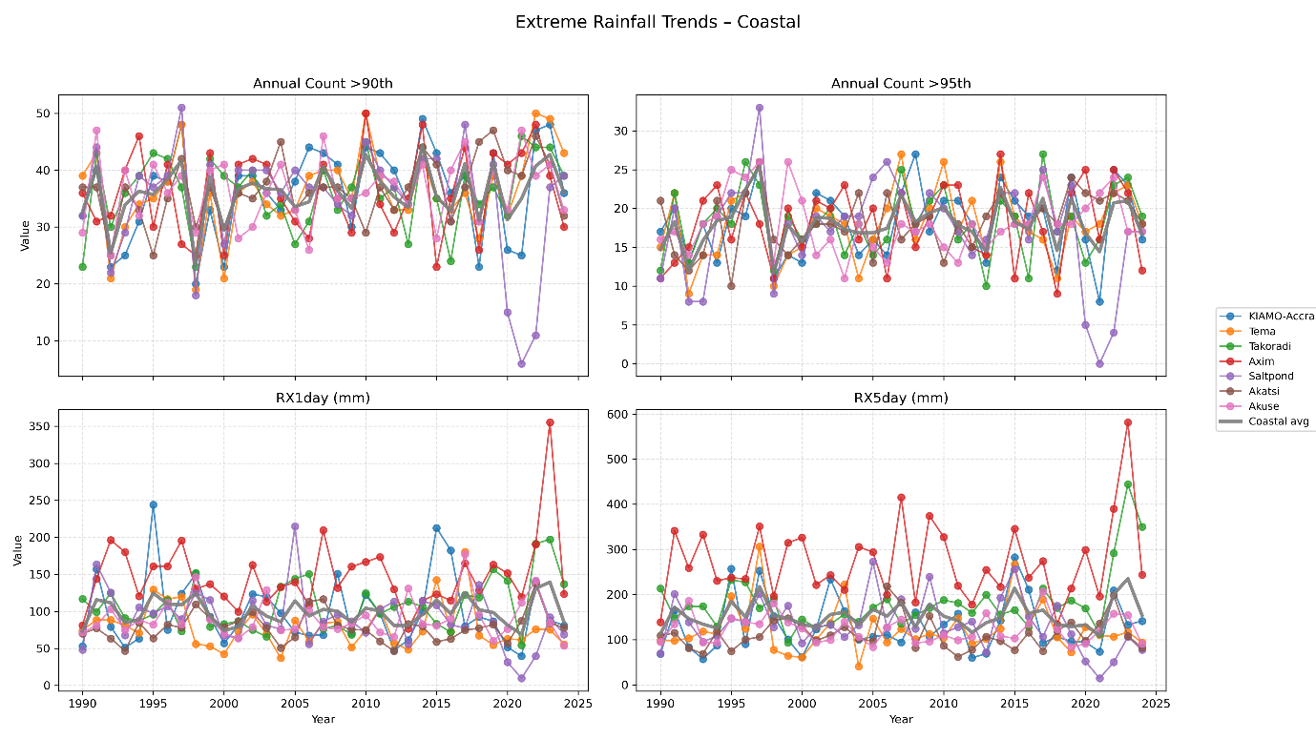

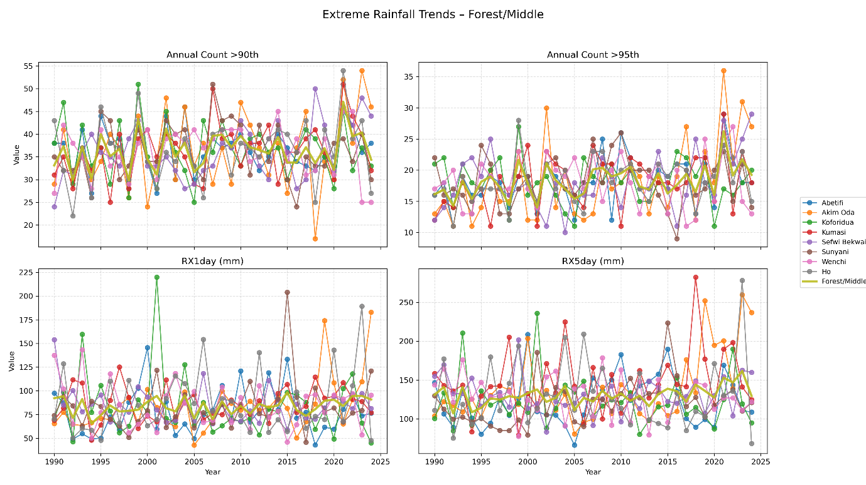

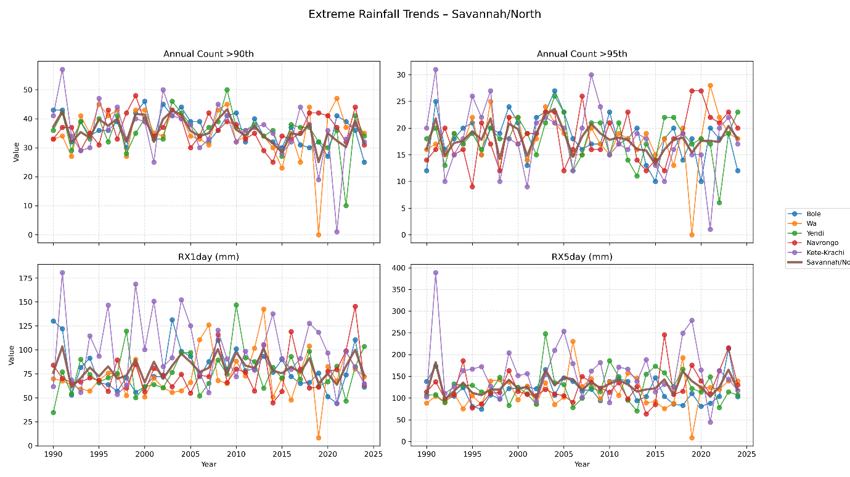

4.1.2 Spatial Trends in Extreme Precipitation (Sen’s Slope Analysis) 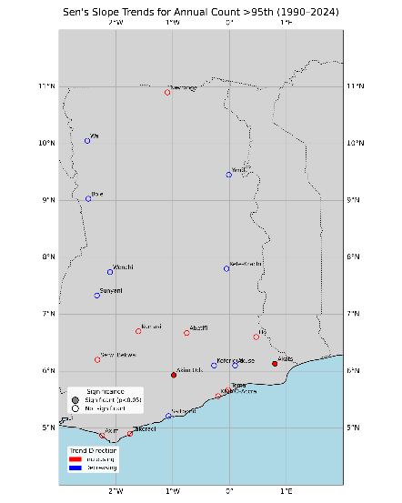 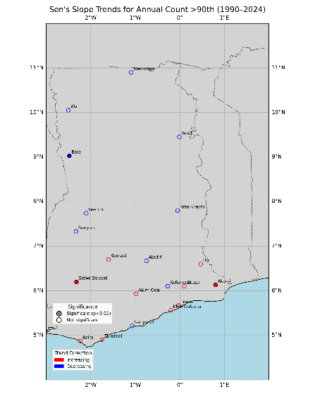

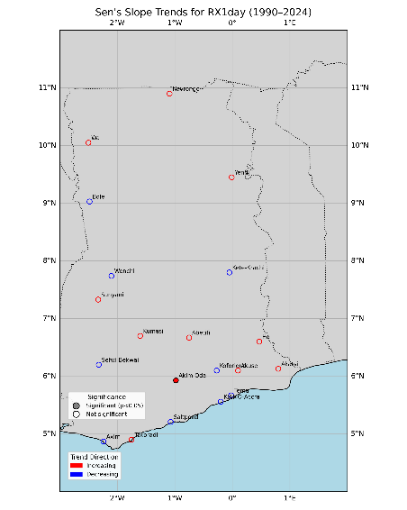 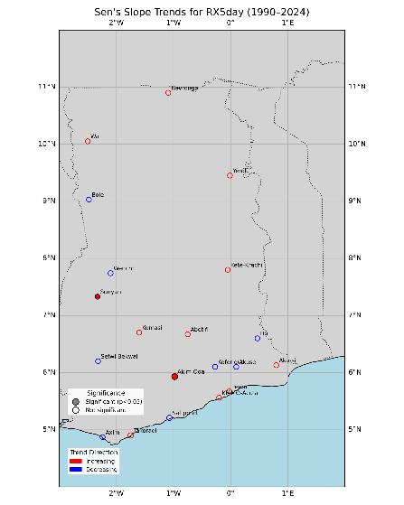

Figure 4.4 to 4.8 present the spatial distribution of Sen’s slope estimates for extreme precipitation indices over the period 1990–2024. The plots show both the direction of change (increasing vs. decreasing), and the statistical significance of the trends (p < 0.05). Together, these maps provide a national-scale perspective on the long-term evolution of extreme rainfall in Ghana.

For the **annual count of extreme rainfall days above the 90th percentile**, several stations in the coastal and forest belts exhibit positive Sen’s slope values, indicating an upward tendency in the frequency of moderate extremes. Notably, stations such as Ho, Akatsi, and Sefwi Bekwai recorded statistically significant increases, underscoring localized intensification in extreme day frequency. By contrast, most northern stations (Bole, Navrongo, Yendi) show negative or near-zero slopes, pointing to declining or stable counts of extremes in the savannah zone.

When considering **exceedances above the 95th percentile**, a similar pattern emerges, although the signal is less spatially consistent. Positive slopes are concentrated in the southern sector (Accra, Tema, Akatsi, Akim Oda), whereas the northern zone again shows declining trends. Importantly, many of these changes are not statistically significant, reflecting the large interannual variability that characterizes rainfall in West Africa.

The **magnitude-based indices (RX1day and RX5day)** further reinforce the spatial gradient. Increasing trends in RX1day are observed across much of the south, particularly around Ho, Akatsi, and Accra, although statistical significance remains limited. RX5day trends show a clearer zonal contrast: several forest and coastal stations (e.g., Sefwi Bekwai, Akim Oda, Accra) indicate significant increases in multi-day extremes, whereas most northern stations display weak or negative slopes. This suggests a strengthening of high-intensity, flood-prone rainfall events in the southern half of the country.

Overall, the Sen’s slope analysis highlights a **south–north gradient in extreme precipitation trends**. The **southern coastal and forest zones** exhibit more frequent and intense extremes, with several stations showing statistically significant increases, while the **northern savannah** is characterized by mixed or declining trends. This finding is consistent with earlier studies that documented a relative intensification of heavy rainfall along the Gulf of Guinea, in contrast to the more drought-prone conditions of northern Ghana. The spatial divergence has important implications for regional planning: coastal urban centers face growing flood risks, while the northern savannah continues to struggle with rainfall deficits and variability.

4.1.3 Decadal Variability and Return Periods of Extreme Rainfall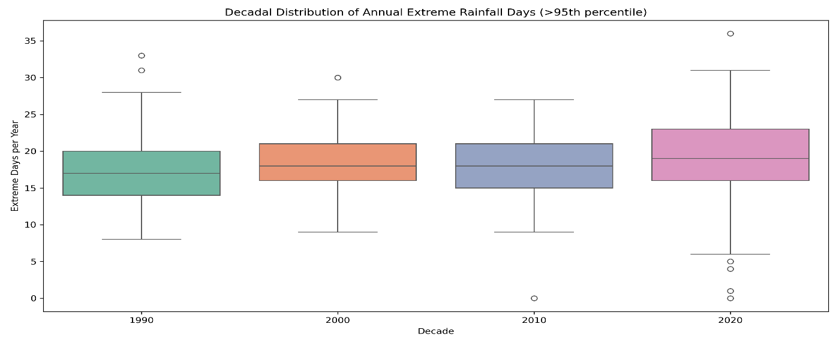

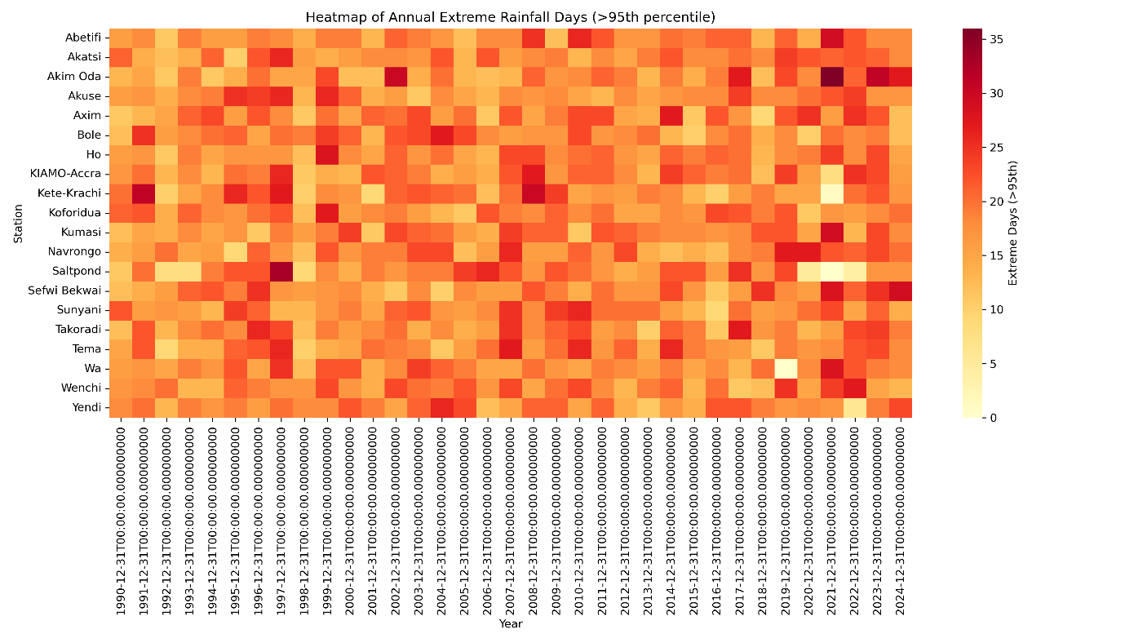

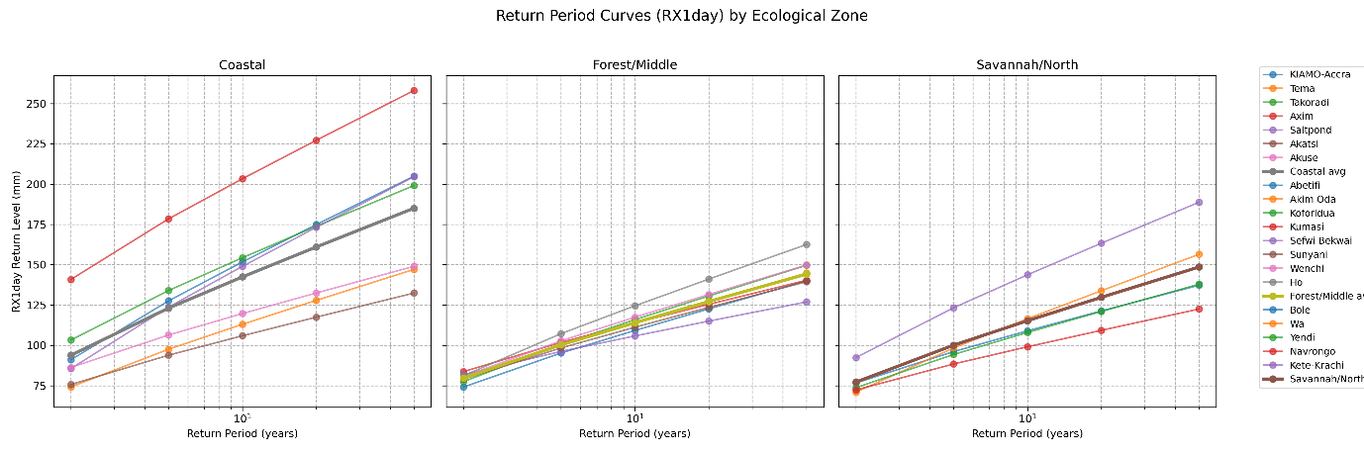

The decadal distribution of extreme rainfall days (Figure 4.9) reveals a gradual upward shift in the central tendency of extremes from the 1990s through the 2020s. Median values in the 1990s were around 17 days per year, rising to nearly 19–20 days in the most recent decade. The interquartile range has also broadened, suggesting greater variability in the frequency of extremes in recent decades. Although the overall increase is modest, the presence of more frequent high outliers in the 2010s and 2020s underscores the growing occurrence of particularly wet years, consistent with intensification signals observed in the coastal and forest zones. This aligns with other West African studies reporting increases in heavy rainfall events despite a relatively stable or declining annual mean rainfall.

The spatiotemporal distribution of extremes is further highlighted in the heatmap (Figure 4.10). While year-to-year variability is evident at all stations, clusters of widespread extremes are apparent during certain years, such as 1991, 2007, 2010, and 2022. These coincide with years of documented floods in Ghana and the wider subregion, reinforcing the linkage between national disaster records and extreme rainfall diagnostics. The heatmap also reveals regional contrasts: coastal and forest stations (e.g., Takoradi, Ho, and Accra) frequently record higher extreme-day counts compared with the more variable northern stations such as Wa and Navrongo. Such heterogeneity underscores the role of local climatic and topographic factors in modulating extremes.

The magnitude of rare events, expressed as return levels of RX1day, demonstrates substantial zonal differences (Figure 4.11). Along the coast, return levels for 10-year events frequently exceed 150–200 mm, with some stations such as Axim projecting over 250 mm for 20-year return periods. By comparison, forest-zone stations cluster around 100–140 mm for 10-year return levels, while savannah stations generally range between 80–120 mm. Nonetheless, certain savannah locations (e.g., Kete-Krachi, Navrongo) display notably higher return levels than the zonal average, reflecting localized vulnerability to high-intensity rainfall. These findings confirm that the **coastal belt is most exposed to short-duration, high-intensity rainfall extremes**, while the **northern savannah remains vulnerable to less frequent but occasionally severe bursts**.

Taken together, the decadal boxplots, station-level heatmaps, and return-period curves provide strong evidence of a **changing risk profile for extreme rainfall in Ghana**. While interannual and interdecadal variability remains high, the data suggest a tendency toward more frequent and more intense extremes in recent decades, especially in the coastal zone. This corroborates the zonal and Sen’s slope analyses, painting a coherent picture of **increasing hydrometeorological risk in southern Ghana** and more heterogeneous trends in the north.

4.2 Seasonality of Extreme Precipitation Events

The seasonal cycle of extreme precipitation, defined here as rainfall events above the 95th percentile, is shown in Figures 4.12–4.14. The results reveal clear zonal and seasonal contrasts in the timing and frequency of extremes across Ghana’s agro-ecological zones.

The **monthly climatology by ecological zone** (Figure 4.12) indicates distinct rainfall regimes between the coastal, forest, and savannah belts. The coastal zone shows a pronounced **bimodal pattern**, with peaks in May–June and a secondary maximum in September–October, reflecting the well-known “major” and “minor” rainy seasons of the Gulf of Guinea. In contrast, the savannah zone exhibits a **unimodal distribution**, with extreme events concentrated between July and September, corresponding to the single rainy season of northern Ghana. The forest zone displays an intermediate pattern, with two peaks similar to the coast but less sharply defined. These differences highlight the importance of the West African Monsoon and its seasonal migration in shaping extreme rainfall climatology.

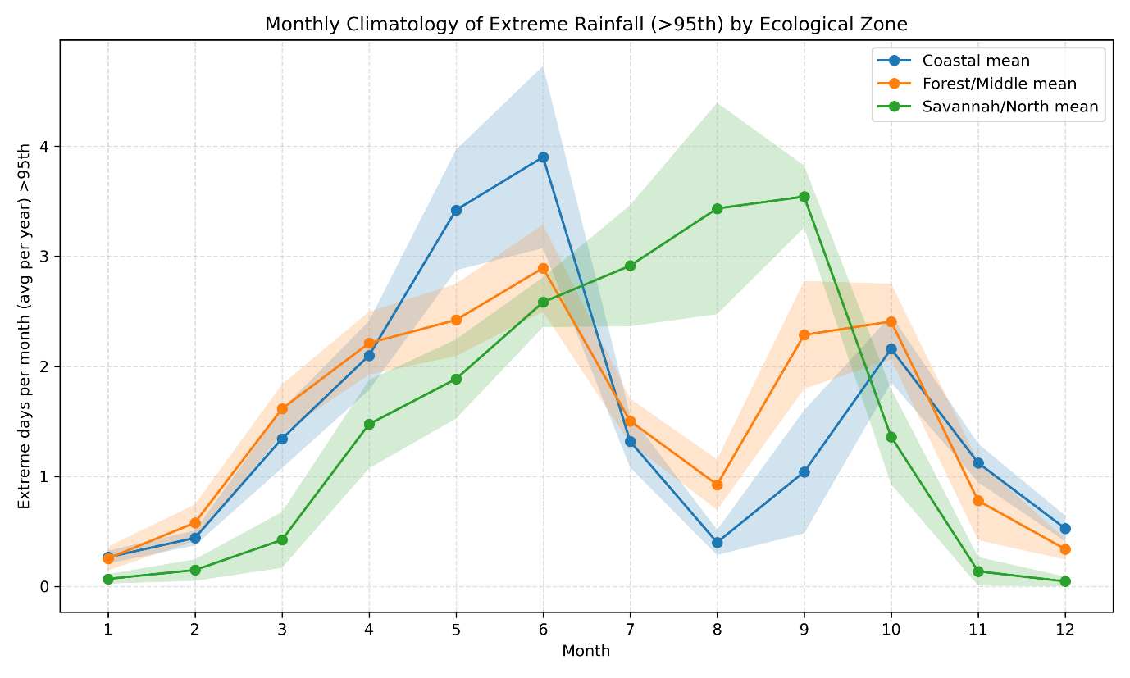

Also, figure 4.13 provide further statistical confirmation of these patterns. Extreme rainfall days are rare in December–February (DJF), which coincides with the dry season across Ghana. The highest frequencies occur during March–May (MAM) and June–August (JJA), with median values exceeding 5–7 extreme days per season. The September–November (SON) season maintains moderate counts, reflecting the minor rainy season in the south and the late monsoon rains in the north. This reinforces the central role of MAM and JJA as the peak seasons for extreme precipitation occurrence.

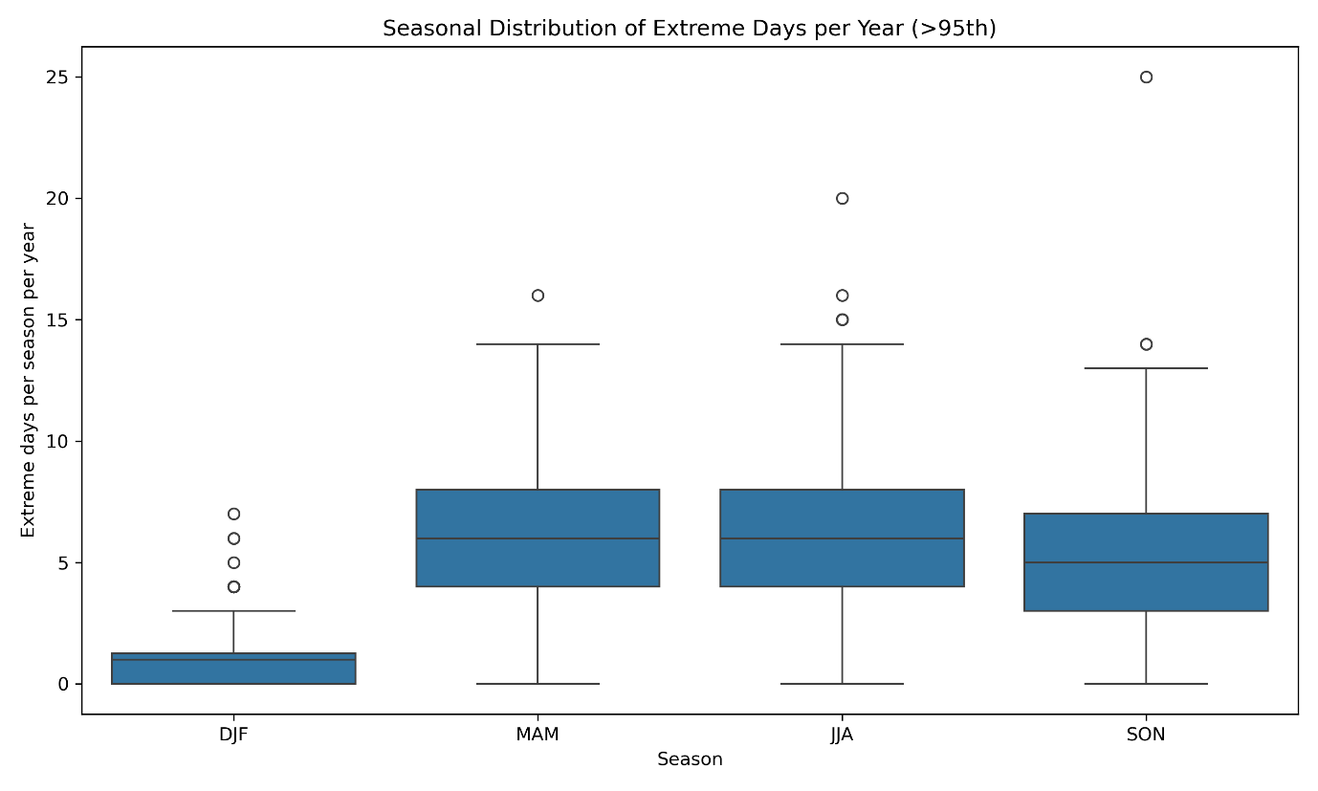

Figure 4.14, adds a finer spatial dimension to the seasonal cycle. Coastal stations such as Takoradi, Saltpond, and Accra register high frequencies of extremes in May–June and again in September, consistent with the bimodal coastal rainfall regime. In the forest zone, stations such as Kumasi and Ho show peaks in May–June with less consistent secondary maxima. Northern stations, particularly Navrongo and Wa, concentrate their extremes in July–September, in line with the unimodal monsoon-driven seasonality. The heatmap also highlights inter-station variability within zones, suggesting that local geographic features (e.g., orography, land–sea interactions) modulate the exact timing and intensity of extremes.

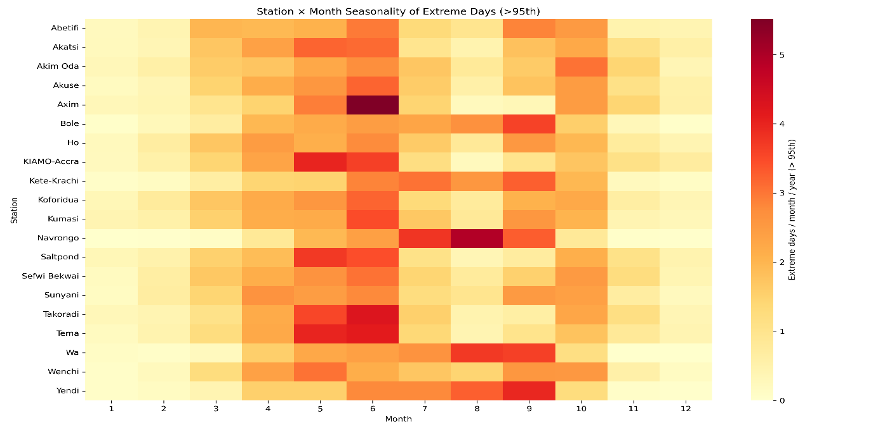

Overall, the seasonality analysis underscores that extreme rainfall in Ghana is **closely aligned with the broader seasonal rainfall regimes of the West African Monsoon system**. The results confirm that the **coastal zone experiences bimodal extreme rainfall peaks**, the **forest zone shows a transitional pattern**, and the **northern savannah is dominated by unimodal extremes**. This zonal differentiation has important implications for agriculture and water resource management, particularly in anticipating the timing of extreme rainfall hazards such as floods.

4.3 Influence of ENSO on Extreme Precipitation in Ghana

The relationship between ENSO variability and extreme precipitation in Ghana was explored using Niño 3.4 sea surface temperature anomalies and their classification into El Niño, La Niña, and Neutral phases. The results are summarized in Figures 4.15–4.17.

The **lagged correlation analysis** (Figure 4.15) indicates that ENSO anomalies are weakly but consistently related to the occurrence of extreme rainfall days. At zero lag, the correlation is slightly negative (r ≈ –0.02), suggesting that El Niño conditions tend to suppress extreme rainfall, while La Niña conditions tend to enhance them. Importantly, the correlation becomes progressively more negative when ENSO leads by 1–4 months, reaching its strongest values around a 4–5-month lead (r ≈ –0.08). This implies that ENSO anomalies in boreal spring and early summer may exert an influence on Ghana’s rainfall extremes during the main rainy season, consistent with the delayed teleconnection of ENSO on the West African monsoon system.

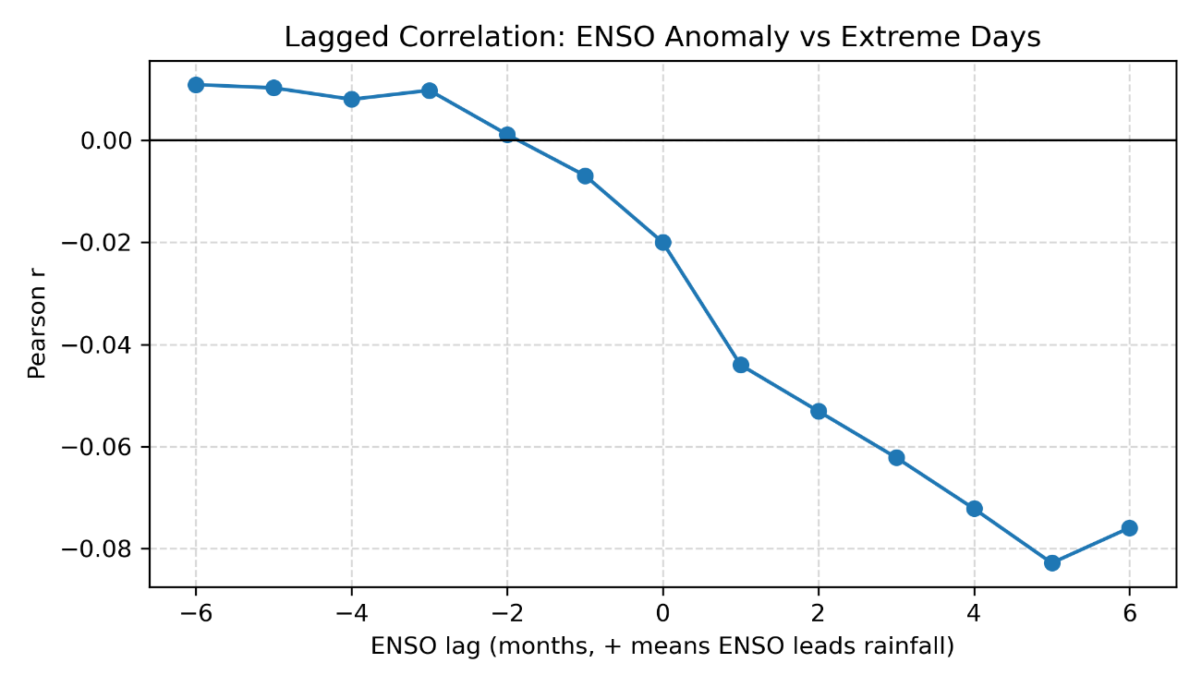

The **phase-based analysis** further supports this interpretation. The boxplots of extreme rainfall days by ENSO phase (Figure 4.16) show that **Neutral phases** are associated with the highest median number of extremes, followed by La Niña, with El Niño months recording the lowest extremes. The composite means (Figure 4.17) highlight that neutral months average approximately 35 extreme rainfall days (summed across all stations), compared to 26–27 days during La Niña and El Niño conditions. This asymmetry suggests that while ENSO influences extremes, its role is not deterministic; extremes can occur under all phases, but Neutral conditions appear most favorable for widespread rainfall extremes.

The relatively weak correlations underscore that the **ENSO–extreme rainfall link in Ghana is indirect and modulated by other regional drivers**, such as the Atlantic Niño, tropical Atlantic SST gradients, and the position of the Intertropical Convergence Zone (ITCZ). Nonetheless, the consistent negative correlation between ENSO anomalies and extreme rainfall frequency suggests that El Niño episodes generally suppress, while La Niña episodes tend to enhance, extreme rainfall over Ghana. These findings are in agreement with earlier studies (e.g., Joly & Voldoire, 2009; Nicholson, 2013), which noted ENSO’s influence on West African rainfall variability, albeit with stronger effects in the Sahel compared to the Guinea Coast.

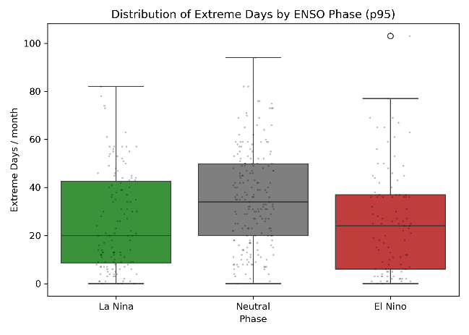 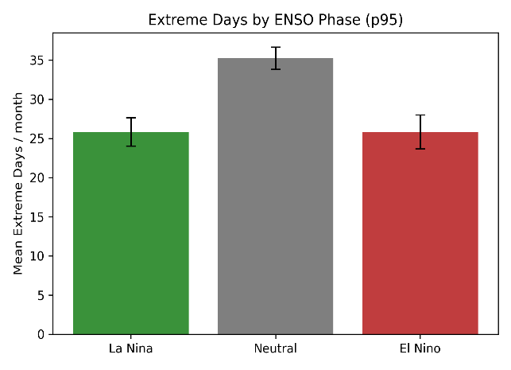

In practical terms, this analysis highlights the importance of considering **ENSO phase as a contributing but not dominant predictor** of extreme rainfall risk in Ghana. The observed lagged influence suggests that monitoring ENSO conditions several months ahead of the rainy season can provide useful early warning signals for hydrometeorological preparedness, especially when combined with regional Atlantic indices and local atmospheric predictors.

**CHAPTER FIVE: Conclusions and Recommendations**

**5.1 Conclusions**

This study examined the long-term variability, seasonal distribution, and large-scale drivers of extreme precipitation across 22 synoptic stations in Ghana over the period 1990–2024. The results demonstrate that extreme rainfall is highly variable both in time and space, yet consistent patterns emerge when the country is viewed across its three ecological zones. In terms of long-term trends, the analysis revealed that the frequency and intensity of extremes have increased more noticeably along the coastal and forest belts, where several stations recorded significant upward slopes in RX1day and RX5day indices. By contrast, the northern savannah generally exhibited flat or declining trends, reflecting its greater vulnerability to both drought and irregular bursts of intense rainfall. Return period analysis confirmed that the coastal zone is most exposed to high-intensity rainfall events, with 10-year RX1day levels commonly exceeding 150–200 mm, compared with 80–120 mm in the northern sector.

The seasonality of extremes closely aligns with the broader climatological regimes of the West African monsoon system. Coastal stations displayed a marked bimodal cycle, with peaks in May–June and September–October, while the savannah exhibited a unimodal distribution with extremes concentrated in July–September. The forest zone fell between these regimes, showing elements of both but with less sharply defined peaks. These patterns highlight the importance of MAM and JJA as the dominant seasons of extreme rainfall occurrence, carrying significant implications for agriculture, flood preparedness, and water resource management.

The influence of ENSO on Ghana’s extremes was found to be modest but consistent. El Niño conditions generally suppressed extremes while La Niña tended to enhance them, with the effect most apparent when ENSO anomalies led rainfall by about four to five months. Surprisingly, neutral ENSO conditions were associated with the highest number of extreme rainfall days, indicating that local and Atlantic drivers exert a stronger influence than ENSO alone. Overall, this study provides evidence that extremes are becoming more intense in southern Ghana, strongly modulated by seasonality, and partly influenced by ENSO, thereby underscoring the growing risks of hydrometeorological hazards in the country.

**5.2 Recommendations**

The findings carry important implications for policy, practice, and research. The increasing intensity of extremes along the coast calls for stronger urban flood preparedness, particularly in cities such as Accra and Takoradi where drainage, zoning, and early warning systems are already under pressure. In the forest and savannah zones, agricultural planning would benefit from aligning crop calendars with the observed timing of extremes, particularly the concentration of events during MAM and JJA. Extension services and local advisory programs should integrate seasonal forecasts of extremes to help farmers mitigate crop losses and optimize planting decisions. At the national scale, ENSO monitoring should be incorporated into early-warning frameworks, as anomalies detected in boreal spring may provide several months of lead time before the rainy season. Nonetheless, ENSO signals should be interpreted alongside Atlantic and regional climate indicators, which appear to play a stronger role in modulating Ghana’s rainfall extremes.

Future research should seek to integrate multiple large-scale drivers such as the Atlantic Niño, the Atlantic Meridional Mode, and the Sahel heat low in order to better explain interannual and decadal variability in extremes. High-resolution regional climate modeling is also needed to capture the influence of urbanization, land–sea interactions, and orographic effects on rainfall intensity. Finally, linking observed extremes to hydrological and socio-economic impacts would enhance the policy relevance of this work, while extending the analysis with satellite rainfall products and downscaling methods would strengthen the robustness of spatial coverage in areas with sparse station data.